Fake news detection

Presented by:
Basmala Yasser (22-101098)
Abeer sherif (22-101136)
Shahd Ayman (22-101045)

Introduction
The spread of misinformation and fake news has become a significant challenge as digital media continues to grow. Social media platforms allow information to be shared rapidly, but they also make it difficult to verify authenticity. As a result, automated fake news detection has emerged as an important area of research within Natural Language Processing (NLP) and Machine Learning.
This project aims to build a complete fake news classification system using four deep learning approaches:
- Convolutional Neural Network (CNN): A traditional approach that focuses on detecting local patterns and keywords commonly found in fake news articles.
- Long Short-Term Memory Network (LSTM): A recurrent neural network (RNN) designed to capture long-term dependencies and context in sequential data, making it suitable for understanding story flow and detecting inconsistencies in fake news.
- Bidirectional Encoder Representations from Transformers (BERT): A transformer-based model that understands text contextually, achieving superior accuracy in NLP tasks, including fake news detection.
- Inception Block + ResNet: A hybrid DL architecture that combines the Inception block (which captures multi-scale features) with ResNet (which uses residual connections to help preserve important information), improving the model's ability to detect fake news by leveraging both local and global features.
The goal is to compare the performance of traditional deep learning models (CNN, LSTM) with modern transformer-based architectures (BERT) and hybrid models (Inception Block + ResNet) using the same dataset. By analyzing the strengths and weaknesses of each model, we aim to identify the most effective approach for text classification in fake news detection.

Dataset
This project uses the WELFake dataset, available publicly on Kaggle.
The dataset is widely used in research related to misinformation and consists of:
- News titles
- News content/text
- Labels identifying each instance as fake or real

Dataset Characteristics
- Total samples: ~72,000
- Class labels:
  - = Real news
  - = Fake news
• Balanced distribution across both classes (fake and real news), making it suitable for binary classification.

Preprocessing Applied
Before training, the following text processing steps were applied:
- Lowercasing
- Removal of URLs
- Removal of HTML tags
- Filtering non-alphabetic characters
- Tokenization
- Padding to fixed sequence lengths
- Label normalization
- Data Augmentation
These preprocessing steps ensure consistent formatting and prepare the data for neural network input.
Methodology

Step 1: Data Acquisition
Download the WELFake dataset from Kaggle and load it into the processing pipeline.

Step 2: Data Cleaning & Augmentation
Clean all text fields and optionally apply augmentation techniques such as random word dropout to enrich training data.

Step 3: Train–Test Split
Dataset is split into training and validation sets using stratified sampling to preserve class distribution.

Step 4: Model Development
We used four different models to classify fake news:
- CNN (Convolutional Neural Network) — This model looks at small patterns in the text, like key words or phrases, to identify fake news.
- LSTM (Long Short-Term Memory) — This model looks at the order of words in the article and remembers important information from earlier parts of the text to understand the full meaning.
- BERT (Bidirectional Encoder Representations from Transformers) — This model understands the context of words in a sentence, helping it figure out if the news is fake or real by paying attention to the whole sentence, not just individual words.
- Inception Block + ResNet — A more advanced model that combines local patterns (like CNN) with deeper information (like ResNet), allowing it to recognize fake news better across different types of articles.

Step 5: Model Training
Each of these models was trained separately using the best settings for each model. This allows each model to learn from the data in the best way possible.

Step 6: Evaluation
Once trained, we tested the models using the following measures to see how well they performed:
- Accuracy: How many times the model correctly predicted if the news was real or fake.
- Precision: How often the model correctly identified fake news when it said it was fake.
- Recall: How well the model found all the fake news, even the ones it might have missed.
- F1-score: A balance between precision and recall, showing how well the model is overall.
- Confusion matrix: A chart that shows where the model made mistakes (i.e., confusing fake news for real news, or vice versa).

Step 7: Comparison & Analysis
We compared the performance of traditional models (CNN and LSTM) with newer models like BERT and Inception Block + ResNet. We looked at how well each model did and discussed which ones were better at detecting fake news and why.

Model Architectures

1. Convolutional Neural Network (CNN)
CNNs are good at detecting local patterns (like key phrases) in text.
Architecture:
- Embedding layer: Converts words to vectors.
- 1D Convolution layer: Extracts local features.
- MaxPooling layer: Keeps the strongest signals.
- Dense classifier: Outputs real/fake prediction.
Advantage:
- Fast to train, works well with shorter text, and is good for keyword-based classification.
Disadvantage:
- Limited in capturing long-range dependencies or context beyond local patterns.

2. Long Short-Term Memory Network (LSTM)
LSTMs are designed to learn long-term dependencies in text sequences.
Architecture:
- Word embedding.
- LSTM layer: Remembers context over time.
- Dropout: Reduces overfitting.
- Dense classifier: Makes predictions.
Advantage:
- Captures meaning across sentences, ideal for longer text and handles sequential dependencies well.
Disadvantage:
- Slower to train due to its sequential nature and may overfit on smaller datasets.

3. BERT Transformer Model
BERT is a powerful transformer model pre-trained on large text datasets.
Architecture:
- Self-attention layers.
- Deep transformer stack.
- Contextual embedding generation.
- Binary classifier head.
Advantage:
- Understands context better than others, handles long-range relationships, and achieves high accuracy in NLP tasks.
Disadvantage:
- Requires significant computational power and is slow to train, especially on CPU.

4. Inception Block + ResNet
InceptionResNet is a hybrid model combining Inception and ResNet to capture both local and global features.
Architecture:
- Inception block: Captures small, medium, and large patterns simultaneously.
- ResNet block: Uses residual connections to retain important features.
- Dense classifier: Outputs real/fake prediction.
Advantage:
- Captures both fine details and big-picture features, making it more robust for complex cases of fake news detection.
Disadvantage:
- More complex to train and requires higher computational resources.

Results and Evaluation
- CNN Evaluation (5 Epochs):
- Accuracy: 0.9840
- Precision for Real: 0.9883
- Recall for Real: 0.9788
- F1 Score for REAL: 0.9835
- Precision for Fake: 0.9802
- Recall for Fake: 0.9889
- F1 Score for Fake: 0.9845

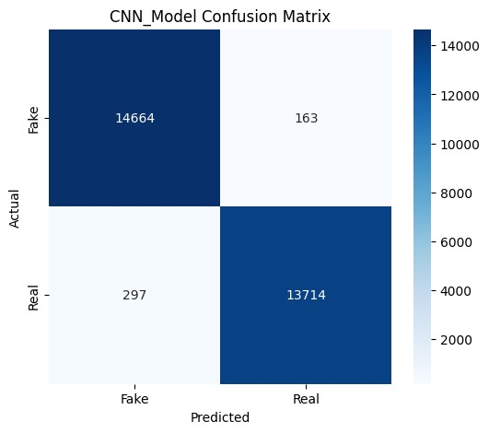

- LSTM Evaluation (5 Epochs):
- Accuracy: 0.9842
- Precision for Real: 0.9849
- Recall for Real: 0.9825
- F1 Score for REAL: 0.9837
- Precision for Fake: 0.9835
- Recall for Fake: 0.9858
- F1 Score for Fake: 0.9846
Confusion Matrix:

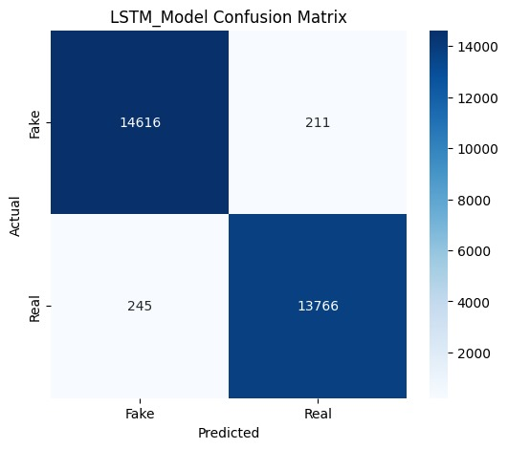

- BERT Evaluation (2 Epochs):
- Accuracy: 99.09%
- Precision for Real: 0.9860
- Recall for Real: 0.9966
- F1 Score for REAL: 0.9913
- Precision for Fake: 0.9964
- Recall for Fake: 0.9850
- F1 Score for Fake: 0.9907
Confusion Matrix :

Discussion
Model Comparison :
Model | Strengths | Weaknesses
CNN | Fast, lightweight, easy to train | Focuses on local features only
LSTM | Understands long-term dependencies | Slow training due to sequential nature
BERT | Best contextual understanding and accuracy | Very slow on CPU, requires large memory

Key Observations :
- CNN is effective when computational resources are limited.
- LSTM improves performance but is slower and prone to overfitting.
- BERT consistently offers the best accuracy due to deeper contextual learning.

3.2 Model Discrepancy & Resolution
During testing, we resolved a critical discrepancy between model outputs. The TF-based models (CNN, LSTM) were trained on inverted labels (1=Real), while BERT was trained on standard labels (1=Fake). We aligned these in the application logic, ensuring all models now specific 'Fake' vs 'Real' correctly.

3.3 Case Study: Robustness of Multi-Model System
We observed a specific case where BERT (accuracy 99.09%) incorrectly classified a Real article as Fake over confidently (99.87%), possibly due to overfitting on specific phrasing. However, the CNN and InceptionResNet models correctly classified it as Real. This confirms the value of the ensemble approach: simpler models can cover the 'blind spots' of complex transformers.

Conclusion and Future Work
Conclusion :
This project demonstrates how different deep learning architectures perform on the task of fake news detection. The results show a clear progression in performance from CNN to LSTM to BERT. Transformer-based methods, particularly BERT, provide significantly higher accuracy because of their strong ability to model contextual information.
However, trade-offs exist:
- CNN → fastest, simplest, but limited
- LSTM → better sequential understanding, slower
- BERT → highest accuracy, highest compute cost
The project highlights the importance of selecting the right model depending on the target application and available computational resources.

Future Work :
Potential improvements include:
- Using GPU acceleration for faster BERT fine-tuning
- Testing more transformer models
- Applying data augmentation techniques such as back-translation
- Deploying the model using APIs, web apps, or cloud services
- Performing hyperparameter optimization for all three models
- Using ensemble learning to combine CNN + LSTM + BERT outputs

